THE INFLUENCE OF THE REINFORCEMENT ANGLE OF A COMPOSITE BLADE ON THE STRENGTH PROPERTIES OF A MINI UAV PROPELLER

Andriy Ivanenko,
Department of Applied Mechanics and Materials Engineering
State University “Kyiv Aviation Institute”
Superviser: Denis Ivanenko, PhD,
Department of Applied Mechanics and Materials Engineering
State University “Kyiv Aviation Institute”

Keywords: composite, blade, strength, UAV, CAE (5-10 Keywords)
Text text text text text text text text text text text text text text text text text text text text text text text text text text text text text text text text text text text text text text text text text text text text text text text text text text text text text text text text.
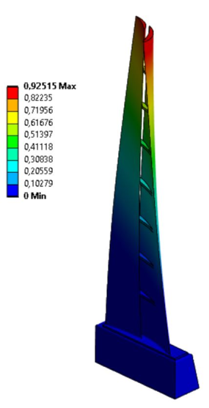
Figure 1. Composite blade
Text text text text text text text text text text text text text text text text text text text text text text text text text text text text text text
$∂_{t}u-v∆u+\left(u∙∇\right)u+∇p=f, ∇∙u=0$ . (1)
Text text text text text text text text text text text text text text text text text text text text text text text text text text
Conclusions. text text text text text text text text text text text text text text text text text text text text text text text text text text text text text text text text text text text text text text text text text text text text text text text text text text text text text text text text text text text text text text text.
References
1. Katnam, K. B., Comer, A. J., Roy, D., Da Silva, L. F. M., & Young, T. M. (2015). Composite repair in wind turbine blades: an overview. The Journal of Adhesion, 91(1-2), 113-139. doi: 10.1080/00218464.2014.900449

